Appendix 3 – MRLC National Land Cover Data Viewer

The Multi-resolution Land Characteristics Consortium (MRLC) National Land Cover Database (http://www.mrlc.gov/) is a project to classify the land cover or land use of the entire US, at a resolution of 30 m x 30 m, based on remote sensing data from satellite imagery. The US is categorized into 21 classes of land use or land cover (4 classes limited to Alaska). When the data is visualized, each of the classes is shown in a unique color. Currently there are publicly available data for 1992, 2001, and 2006. In principal, a new land cover / land use map will be produced every 5 years by the consortium. For the 2001 and 2006 National Land Cover Data (NLCD), there are two additional coverages: a map of impermeable ground cover (e.g. asphalt, cement), and a map of % tree canopy cover. Users of the 2006 NLCD should read the Product Description and Legend (from the home page, click Finding Data > National Land Cover Database 2006).
To visualize land cover data around a point, open the MRLC Consortium Viewer (http://gisdata.usgs.gov/website/mrlc/viewer.htm). On the left side of the view window are numerous buttons to activate features (see Fig. 1). Scrolling over the buttons tells what they are. Useful features include Legend (under Documents), and the Measure and Eraser (under Tools). The button XY opens a window to enter longitude and latitude. Entering the long-lat (decimal degrees required, format longitude, latitude: -91.6300661, 44.0615459) and hitting return will zoom the view window to that location. Each color represents a different land use / land cover class; a key is provided in Fig. 2 . More detailed instructions on using the Viewer are at http://gisdata.usgs.gov/website/mrlc/userinstructions.htm .
In the upper right of the view window is the Scale Information. You can use this to change scales down to 1:52 inches – too fine a scale to be of use. Below the scale information is the Display. You can display various coverages, including overlays. For example, you can overlay city names, hydrology, roads, and political boundaries over the 2006 NLCD. To access a coverage, click the check box next to the coverage name. If the feature Legend button has been clicked on the left-side panel, the legend for each display coverage will be shown (see Fig. 2). Make sure that the 2006 NLCD (CONUS) Land Cover check box is checked, and all other boxes are unchecked.
To analyze land use / land cover around a desired point (e.g. a specified point count location), enter the longitude and latitude (e.g. -91.6300661, 44.0615459). Select the desired scale, using the Scale Information tool. Click the Eraser to remove the geocoordinate label from the view window. Make sure that no coverage is checked in the Display except the 2006 NLCD (the default view has the Boundaries – National Atlas States checked, so uncheck this). Finally, make a screen grab of the landscape visualization (using Windows Snipping Tool, or the Mac OS see http://www.wikihow.com/Take-a-Screenshot-in-Mac-OS-X ) to copy the section of the land use image you intend to analyze. Paste the grabbed image into a new ImageJ image file (see Appendix 4).
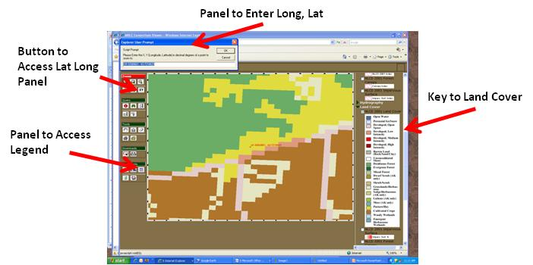
Fig. 1. The MRLC Consortium Viewer of the NLCD, showing some of its main features.
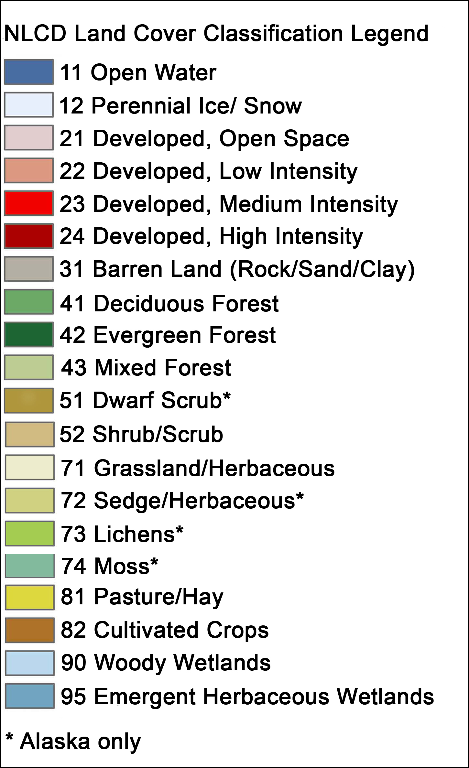
Fig. 2. Color key of land cover / land use classes of the 2006 NLCD.

